https://www.analyticsvidhya.com/blog/2020/04/confusion-matrix-machine-learning/
https://www.datacamp.com/tutorial/what-is-a-confusion-matrix-in-machine-learning

Key Components of a Confusion Matrix
- True Positive (TP): Predicted positive and actually positive.
- True Negative (TN): Predicted negative and actually negative.
- False Positive (FP - Type I Error): Predicted positive but actually negative.
- False Negative (FN - Type II Error): Predicted negative but actually positive.
 | Predicted: Positive | Predicted: Negative
Actual: Positive | True Positive (TP) | False Negative (FN)
Actual: Negative | False Positive (FP) | True Negative (TN)

Derivations:
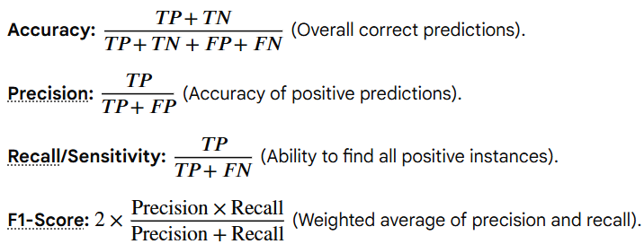

Confusion Matrix Example (Numerical)
Scenario
A machine learning model is trained to classify emails into two categories:
- Spam (Positive class)
- Not Spam (Negative class)
We test the model on 20 emails.

Step 1: Actual vs. Predicted Outcomes
Out of 20 test emails:
- Actual Spam emails = 10
- Actual Not Spam emails = 10
The model predictions:
- Correctly identified 8 spam emails as spam.
- Misclassified 2 spam emails as not spam.
- Correctly identified 7 not spam emails as not spam.
- Misclassified 3 not spam emails as spam.

Step 2: Build the Confusion Matrix
 | Predicted Spam | Predicted Not Spam
Actual Spam | 8 (True Positive) | 2 (False Negative)
Actual Not Spam | 3 (False Positive) | 7 (True Negative)

Step 3: Interpret Each Cell
- True Positive (TP = 8) → Spam correctly predicted as spam.
- False Negative (FN = 2) → Spam wrongly predicted as not spam.
- False Positive (FP = 3) → Not spam wrongly predicted as spam.
- True Negative (TN = 7) → Not spam correctly predicted as not spam.

Step 4: Derive Metrics
From the confusion matrix, we can calculate:
- Accuracy = (TP + TN) / Total = (8 + 7) / 20 = 75%
- Precision (Spam class) = TP / (TP + FP) = 8 / (8 + 3) = 72.7%
- Recall (Spam class) = TP / (TP + FN) = 8 / (8 + 2) = 80%
- F1-score = 2 × (Precision × Recall) / (Precision + Recall) ≈ 76.2%

Key Point
- The confusion matrix shows not just how many predictions were correct, but where the model made mistakes.
- It helps explain why accuracy alone can be misleading — precision and recall give deeper insights.

Confusion Matrix Example (Multi-Class)
Scenario
A machine learning model is trained to classify flowers into three species:
- Class 0: Setosa
- Class 1: Versicolor
- Class 2: Virginica
We test the model on 30 flowers (10 from each species).

Step 1: Actual vs. Predicted Outcomes
- Setosa (10 flowers)
  - Predicted correctly as Setosa: 9
  - Misclassified as Versicolor: 1
  - Misclassified as Virginica: 0
- Versicolor (10 flowers)
  - Predicted correctly as Versicolor: 7
  - Misclassified as Setosa: 0
  - Misclassified as Virginica: 3
- Virginica (10 flowers)
  - Predicted correctly as Virginica: 8
  - Misclassified as Setosa: 0
  - Misclassified as Versicolor: 2

Step 2: Build the Confusion Matrix
 | Predicted Setosa | Predicted Versicolor | Predicted Virginica
Actual Setosa | 9 | 1 | 0
Actual Versicolor | 0 | 7 | 3
Actual Virginica | 0 | 2 | 8

Step 3: Interpret Each Row
- Row 1 (Setosa): 9 correct, 1 misclassified as Versicolor.
- Row 2 (Versicolor): 7 correct, 3 misclassified as Virginica.
- Row 3 (Virginica): 8 correct, 2 misclassified as Versicolor.

Step 4: Derive Metrics (for one class, e.g., Versicolor)
- True Positives (TP) = 7 (Versicolor predicted correctly)
- False Negatives (FN) = 3 (Versicolor misclassified as Virginica)
- False Positives (FP) = 1 + 2 = 3 (Setosa and Virginica wrongly predicted as Versicolor)
- True Negatives (TN) = Remaining = 17
From this:
- Precision (Versicolor) = TP / (TP + FP) = 7 / (7 + 3) = 70%
- Recall (Versicolor) = TP / (TP + FN) = 7 / (7 + 3) = 70%
- F1-score (Versicolor) = 70% (since precision = recall here).

Key Point
- In multi-class classification, the confusion matrix expands into a square grid (rows = actual classes, columns = predicted classes).
- Each diagonal entry shows correct predictions.
- Off-diagonal entries highlight specific misclassifications (e.g., Versicolor often confused with Virginica).
- Metrics like precision, recall, and F1 can be computed per class or averaged across classes.

- Cold: 12 correct, 2 misclassified as Allergy, 1 misclassified as Flu.
- Allergy: 14 correct, 1 misclassified as Cold

